**PRACTICAL –7**

**Q. Write a program to use IR ( Infrared ) Sensor to Raspberry Pi .**

**Hardware:-**

* Raspberry pi
* InfraredSensor (IR)
* LED
* 10k ohm potentiometer
* Breadboard and wires

**Code:-**

import RPi.GPIO as IO  
import time  
IO.setwarnings(False)  
IO.setmode(IO.BCM)

IO.setup(2,IO.OUT) #GPIO 2 -> Red LED as output  
IO.setup(3,IO.OUT) #GPIO 3 -> Green LED as output  
IO.setup(14,IO.IN) #GPIO 14 -> IR sensor as input

while 1:

    if(IO.input(14)==True): #object is far away  
        IO.output(2,True) #Red led ON  
        IO.output(3,False) # Green led OFF  
      
    if(IO.input(14)==False): #object is near  
        IO.output(3,True) #Green led ON  
        IO.output(2,False) # Red led OFF

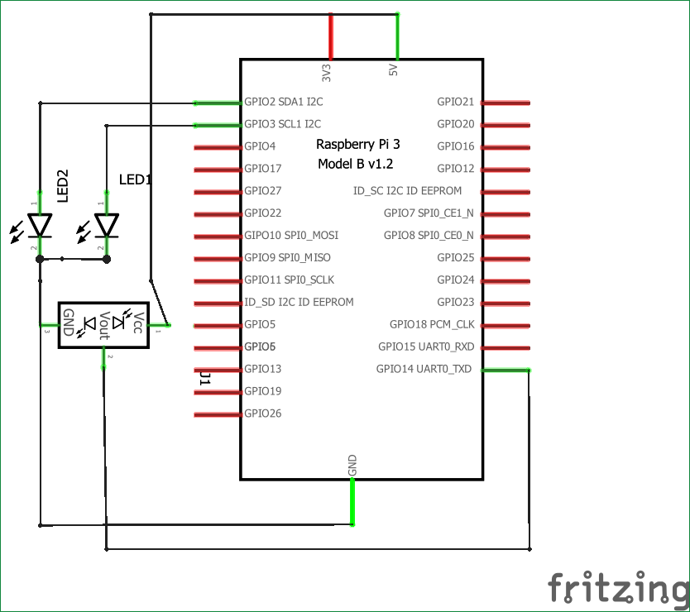

**OutPut:-**

